# MINERALS AND MINING IN AFRICA

# In senior two, you learnt about mining in Africa. you learned about the different minerals in your country. Minerals and mining play a great role in the economic development of people, countries and regions

# In this chapter you are going to learn about the mineral resources in Africa and you will be able to discover how minerals can contribute towards the development of African countries.

Mining is the extraction of minerals / rock ores and natural gas from the earth’s crust.

The extraction of minerals plays an important role in the economic life of most African countries because the account for the bulky of export earnings.

## Understanding the Major mineral and mining centres in Africa

These include:

* + 1. Copper: in Zambia, DRC, south Africa, etc.
    2. Iron ore: South Africa, Liberia, Mauritania, Nigeria Angola, Gabon Guinea, Senegal, etc.
    3. Petroleum: Nigeria, Namibia, Egypt, Libya, Algeria, Morocco Angola, etc.
    4. Diamonds: south Africa, DRC, sie **r**a Leon, Tanzania, etc.
    5. Uranium: south Africa, DRC, CAR, Nigeria, etc.
    6. Gold; Zimbabwe, Ghana, South Africa, DRC, etc.
    7. Coal: south Africa, DRC, Botswana, Namibia Sierra Leon, etc.

**Activity**

**Complete the table below to show the uses of minerals in Africa**

|  |  |
| --- | --- |
| **Minerals** | **Uses** |
| Diamond | Jewelry, cutting edges |
| Copper |  |
| Oil/Petroleum |  |
| Coal |  |
| limestone |  |
| Iron ore |  |

**Activity.**

Use an atlas to draw a sketch map showing mining areas of Africa.

Explaining the methods of mining

Activity.

Use the photograph provided and answer the tasks below.

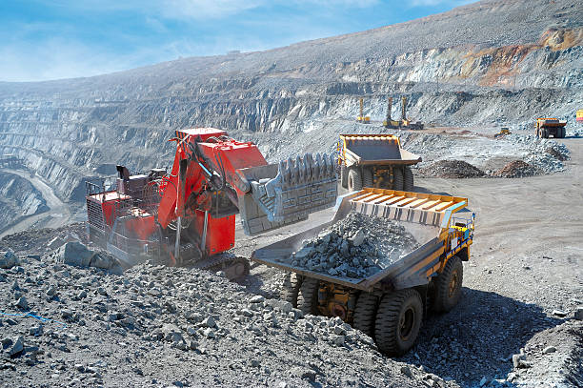

1. Identify the method of mining shown in the photograph.
2. Using evidence from the photograph, explain how the mining method works
3. Explain how it affects the environment in the region.
4. Using diagrams, illustrate and discuss the methods of mining used in Africa.

Solution.

**Open cast:** this is the easiest and cheapest way of extracting minerals that occur close to the surface. It involves the removal of overburden earth and other rock bend lying above the mineral bearing rock. Sometimes blasting is done to loosen the rock. Extraction is done in successive layers until the mineral content becomes too small or too deep to be mined.

Other methods of mining.

Different methods are used to extract minerals depending on the type and depth. The other major methods are:

**Underground mining**: it is used where the ores lies deep belowthe surface with the very thick overburden rock that is too thick to be removed by mechanical shovels. Underground mining has two categories namely:

1. **Adit mining**: this is where horizontal / slightly inclined tunnels are dug into the hill side. Adit mining is used where the mineral ores occur in gently sloping veins on the side of a hill.
2. **Shaft mining**: where Adit mining cannot effectively reach the mineral, vertical shafts are to be used. The vertical shafts may be extended downwards for several hundred kilo meters from the surface.

Vertical shafts / horizontal tunnels are dug to reach the mineral bearing rock. The tunnels are supported by either timber or steel or concrete beams to prevent the roof tops from falling in and must be ventilated and kept free of water.

Explosives may be used to loosen the mineral bearing rock. The mineral ore is then transported by conveyor belts or high railway and brought to the surface lift cages.

1. **Placer mining / panning**: this method of mining is used where the mineral bearing rock has been broken by erosion, transported and deposited by running water. For

example particles of gold, tin and platinum that may occur in sand gravel on the beds of some rivers.

In this case, the sand and gravel are dug out and mixed with water in a shallow circular pan. It is the tilted in such a way that the lighter sand is washed overside leaving the heavier material on the bottom. It is from this material that mineral is extracted.

**Factors which have favoured the development of the mining sector in Africa.**

**Activity.**

**With in your groups or as a pair, carry out library or internet research on the factors favouring mining in Africa**

**Teacher’s response**

1. Presence of extensive/ large deposits of copper. The copper belt covers 50km wide and 110 km long, hence economically viable to exploit fora long time.
2. Nearness of some minerals to the surface, making the use of the cheap open cast method possible.
3. Presence of cheap labour to work in mining sector provided by nationals, since there is no gainful employment in agriculture.
4. Presence of skilled labour provided by foreign companies for high quality production in refining and processing.
5. Availability of large quantities of power supply necessary for processing and smelting mainly got from Kariba dam on river Zambezi and Kafue power station.
6. Presence of large sums of capital mainly provided by foreigners who invest money in extraction and processing of copper.
7. Presence of a large market for mineral and mineral products such as United Kingdom and Japan.
8. Improved transport infrastructure such as the completion of the Tazara railway connecting the copper belt to Dar- es- salaam port forex port.
9. Improved technology like use of machines to increase efficiency, making mining relatively cost- effective/ increasing efficiency.
10. Supportive/ positive government policy towards the mining sector such as tax holidays.

**Understanding the contribution of mineral resources towards development.**

**Activity,**

1. **In groups, carry out textbook or internet research on contribution of mineral resources to the development of Africa.**

**Teachers response.**

* Source of government revenue by taxing people, companies, helping in improving government income and social services.
* Source of foreign exchange by exporting minerals and their products e.g. copper, cobalt, to China, Japan.
* Provision of employment opportunities by working in mines and processing factories leading to high standards of living.
* Growth of urban centres because of increased population, industrial activities helping in promotion of trade and improving social services.
* Promotion of international relations and regional cooperation because of international trade e.g. Japan, China, Britain.
* Improvement in transport and communication like construction of roads, connecting mining areas thus benefiting surrounding communities.
* It has led to the development of industries making mining equipment, processing the mineral and using mineral raw materials and related industries.
* Promotion of economic diversification by influencing other economic activities, trade, transport, industrialization reducing on the dependency burden.
* Promotion of education and research by visiting mining areas, processing factories leading to acquisition of skills and improvement in science and technology.
* Alternative land use in areas with limited resources and other economic activities like dry areas, infertile areas, rocky areas where minerals do exist.
* It has led to improvement in social services like water, power supply, health facilities, education institutions around mining areas.
* Development of tourism industry by visiting the mining areas, earning foreign exchange and because of high incomes leading to entertainment.
* Source of capital for other development projects through taxation, foreign investors through exports.

**Environmental problems resulting from mining sector**

**Activity**

**In pairs carry out text book or Internet research & discuss &write down the problems that have resulted from the mining activities**

**Teacher’s response:**

1. Pollution of the environment in form of noise, dust from the mines and the discharge of toxic wastes from the copper refineries, which causes health complications.
2. Destruction of vegetation where minerals are being extracted and hence destroying the habitat of wild life.
3. Destruction of the soil structure/ disfiguring of the landscape. It is also associated with soil erosion, and slides and general land degradation.
4. There is stagnant water in the hollows/ depressions created, hence breeding of disease-causing vectors. There is also flooding of the mines.
5. Destruction of what would be agricultural land due to large quantities of waste rock debris deposited all over covering the soil.
6. Influx/ movement of people from rural areas to the mining centres which has also reduced agricultural production.
7. Displacement of people due to development of large open cast mining with less or no compensation.
8. Urban—related problems result such as traffic congestion, high crime rate, drug abuse.
9. Emergence of ghost towns where minerals are exhausted and hence the towns abandoned.
10. Regional imbalances in development in terms of infrastructure, since the areas without minerals are given less attention by government.
11. Mining accidents occur leading to loss of life and property

**Ways of solving the above problems**

1. Environmental laws / standards put up to control pollution of the environment.
2. Emphasizing reforestation and afforestation programmes to reduce vegetation depletion.
3. Refilling of the mining pits/ hollows to avoid stagnant water and possible accidents.
4. Spraying with chemicals to kill disease causing vectors and medical treatment of the affected people.
5. Resettling / re- location of the displaced people elsewhere.
6. Strengthening urban authorities and police to control urban problems like drug abuse and high crime rate.

**Understanding the General Problems facing the mining industry in Africa**

**ACTIVITY**

1. **WATCH THE VIDEO CLIP ABOUT MINING AND IDENTIFY THE PROBLEMS SEEN IN THE VIDEO**
2. **With in your groups find out other problems facing the mining sector in Africa**

**SOLUTION**

1. Accidents that may lead to loss of life
2. **Teacher’s contribution**
3. Exhaustion of some mines, since mining has taken place for long.
4. Due to exhaustion of minerals and closure of some mines, ghost towns have emerged with redundant infrastructure.
5. Fluctuation of copper prices on the world market leading to uncertain incomes yet Africa greatly depends on mineral exports.
6. Accidents occur during mineral exploitation leading to loss of life such as due to falling rocks.
7. Limited power supply for the mines
8. Landlockedness of some African countries like Zambia with no direct and easy access to the sea. It has to export through other countries which are often in political unrest such as Zimbabwe, Angola, and DRC.
9. Increasing costs of mining due to increasing depth of the mineral bearing rocks (seams/ layers).
10. Profit repatriation by the foreign owned companies (such as Anglo- American company in Zambia) resulting into loss of revenue.
11. Competition from other countries producing the same mineral types such as USA, DRC, and South Africa which limits the market for Zambian copper.
12. Limited labour supply to work in the mines and the poor working conditions there which limits copper production.
13. Underdeveloped technology and use of depreciated machinery in some areas, which limits efficiency in mining sector.

**Finding out the solutions to the problems**

**Activity**

**In groups or pairs suggest possible solutions to the problems you have mentioned above**

Teacher’s contribution

**Possible ways of solving those problems**

1. Opening alternative routes for copper exports.
2. Building political relations with the neighbors for easy exportation of copper.
3. Opening up new mines where some are exhausted.
4. Carrying out market research to widen the export market for copper.
5. Recruitment of labor from the neighboring counties such as Angola, DRC, Malawi to work in the mines.
6. Replacement of the old and outdated machinery with new modern machinery to increase production.
7. Emphasize processing of mineral ores into manufactured goods to minimize the effects of price fluctuations on the world market.
8. Pumping fresh air into the mines to reduce suffocation.
9. Supporting tunnels to prevent collapsing.

**The Zambian copperbelt**

**Zambia:**

Zambia is rich with mineral resources like copper, cobalt, iron ore, zinc, lead, manganese, Aluminum and the mining areas include Nkona, Bwanamukubwa, Ndola, Kitwe, Chingola, Chibaluma, Chambishi, Bamcraft, Ronentelope, Nampundwe, Kabwe, Kasama.

**A SKETCH MAP OF ZAMBIA SHOWING MAJOR MINING AREAS**

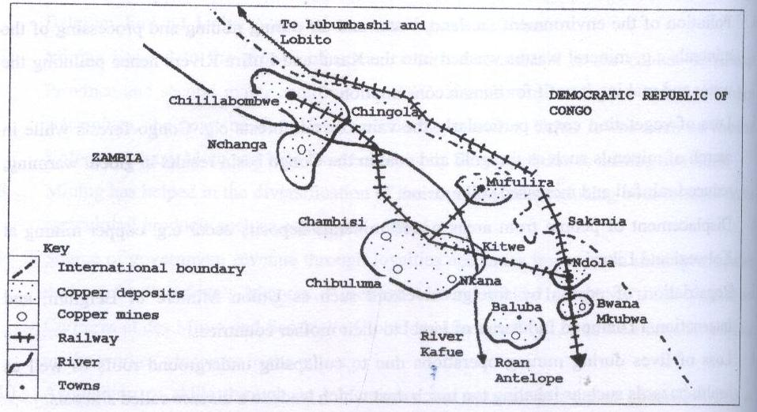

## MINING IN SOUTH AFRICA

South Africa is rich with mineral resources like Gold, Diamond, Oil, Iron ore, Coal, Uranium, Copper and the mining areas with waters Rand, Kimberly, Natal, Cape Province, Drakensberg, Transvaal, Krugersdorp.

**A SKETCH MAP OF S. AFRICA SHOWING MINING AREAS.**

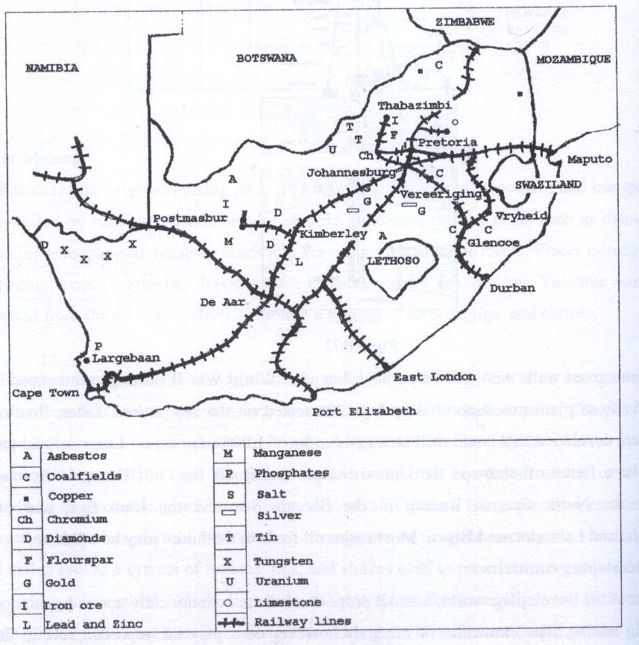

**Activity of integration**

There has been oil exploration in one African country and commercial quantities of oil have been discovered. Plans are underway to begin commercial oil production. The government of that country will be licensing companies to do the oil production. All companies that have applied for oil production are from countries outside Africa. Civil Society Organizations in the country have organized a seminar to discuss and advise government on how best to handle oil production.

You have been invited to make a presentation at the seminar as the only expert who can advise on this matter.

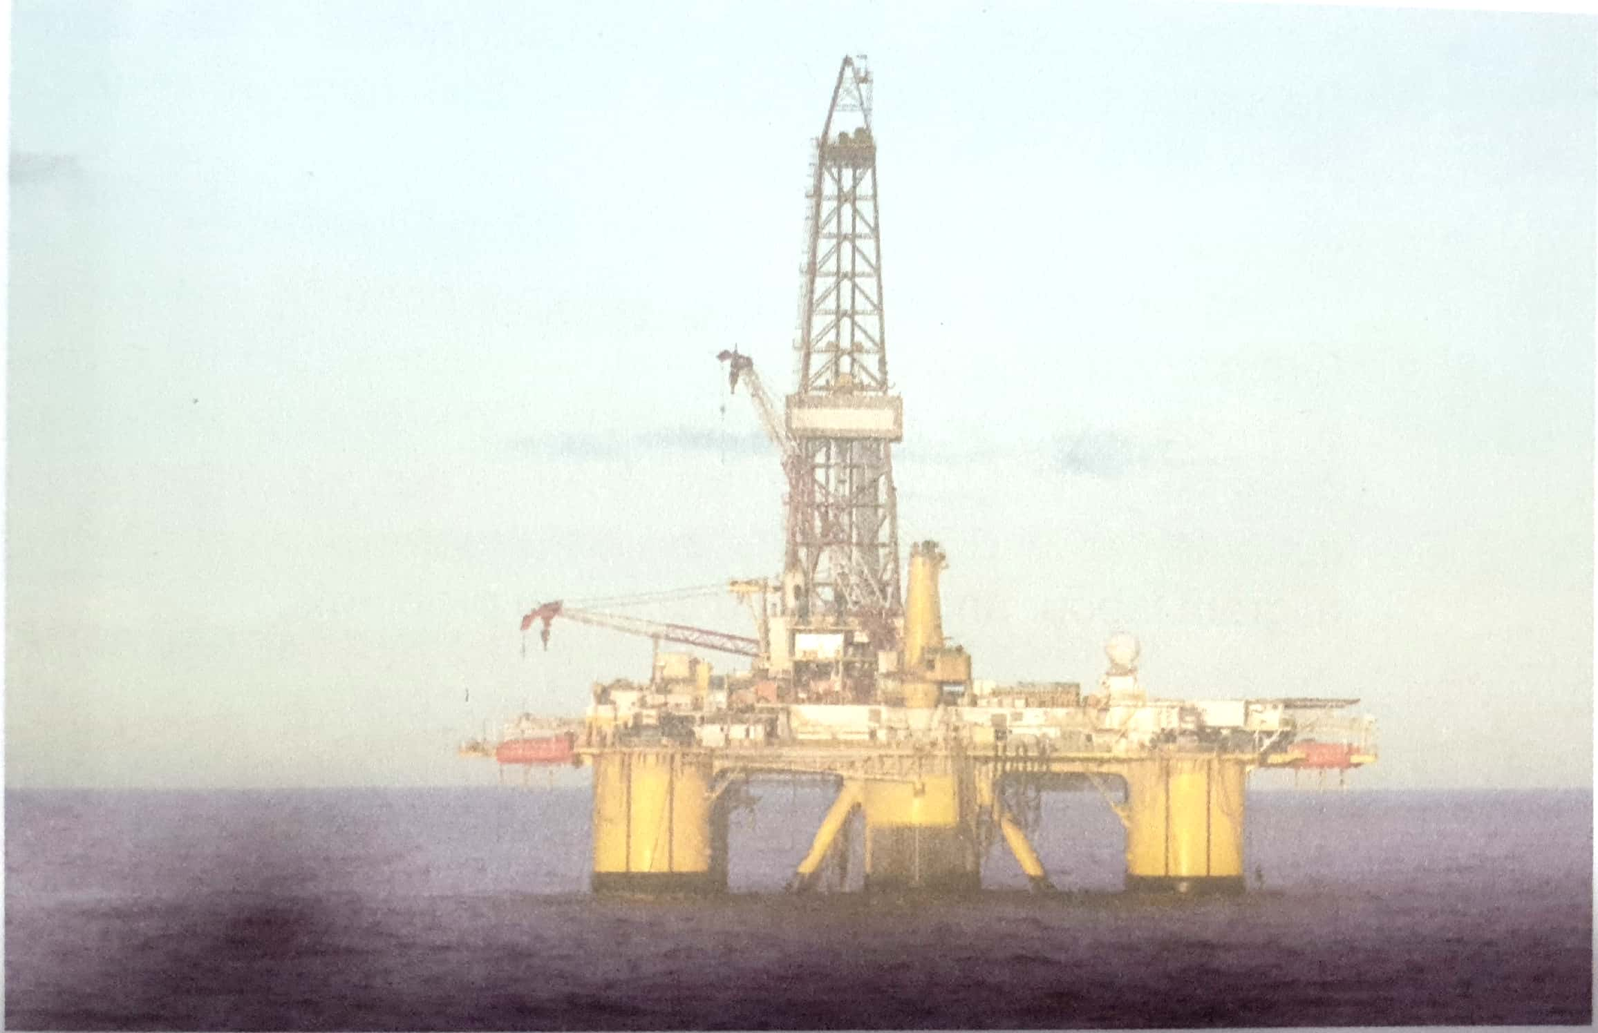

**Task**

Write an advice note of about 400 words that you will present at the seminar